**Flora, Fauna and the Animals found in Mary Cairncross Scenic reserve**

Animals and birds found in Mary Cairncross rain forest:

* + - Red-legged pademelon:

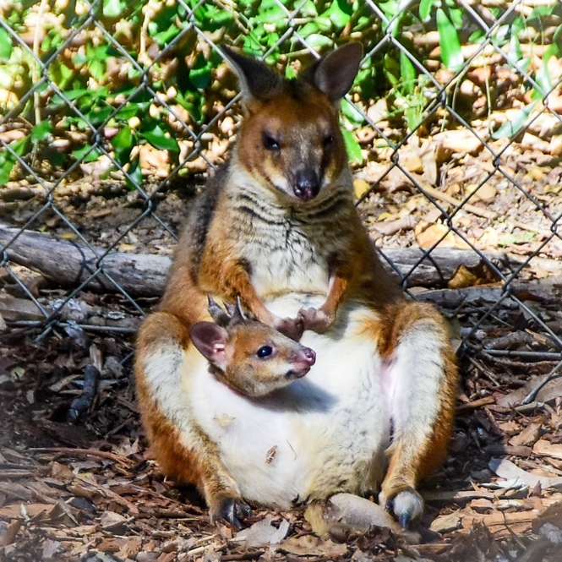

* + - Mountain freshwater crayfish:

* + - Flying Fox: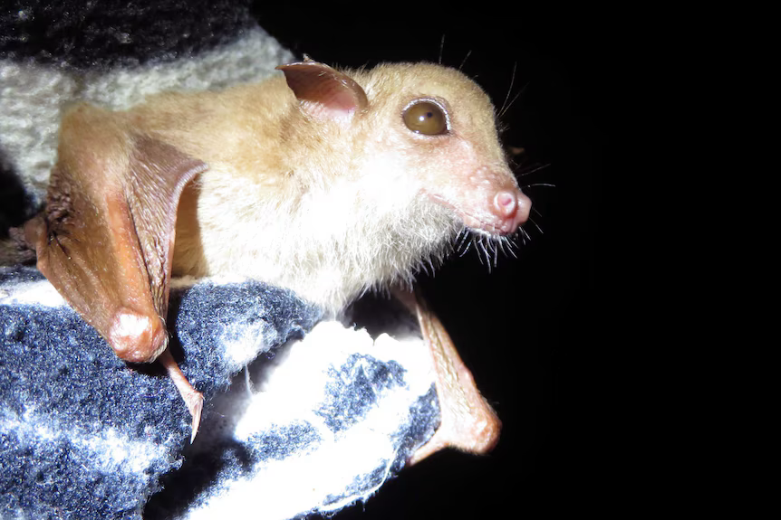

The tiny 6cm-long, nectar and pollen-eating eastern blossom bat has never been recorded in the canopy of the Mary Cairncross Scenic Reserve.

The small fruit bat is listed as vulnerable in NSW, and has been never formally recorded in the 55-hectare Mary Cairncross rainforest reserve.

* + - Southern angle-headed dragon:

* + - Red-bellied black snake:

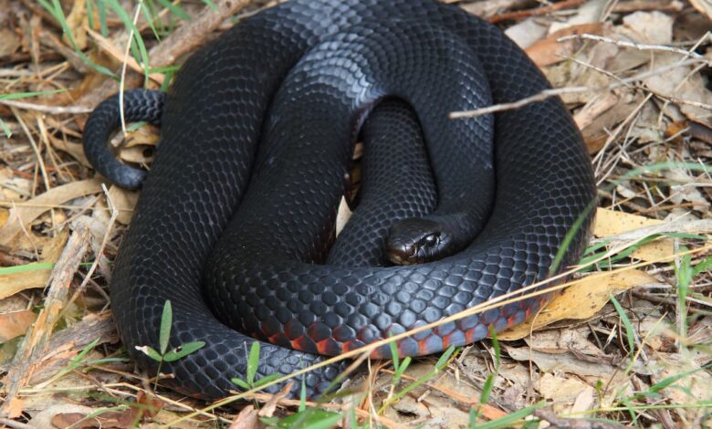

Fruits:

* + - Black apple:

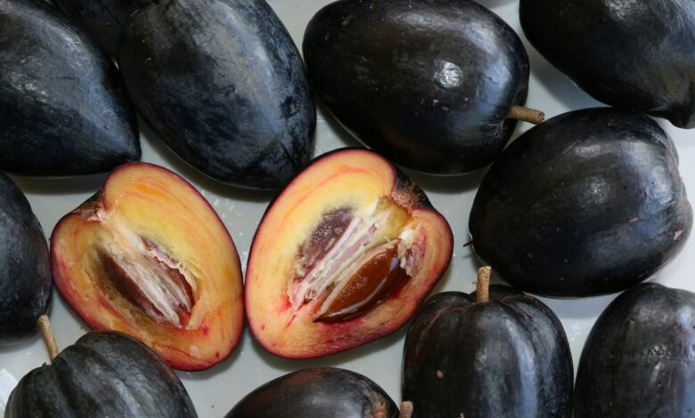

* + - Blue Quandong:

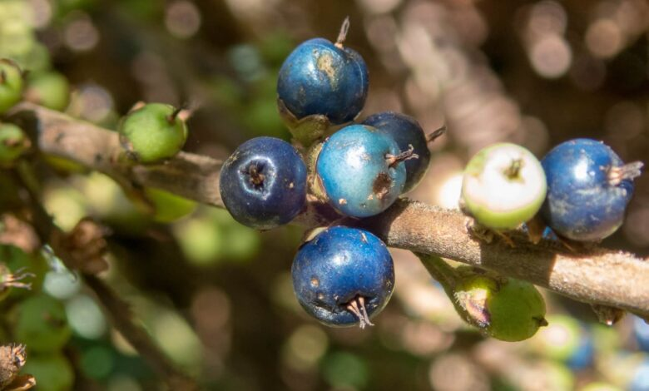

Flowers:

* + - Bleeding heart: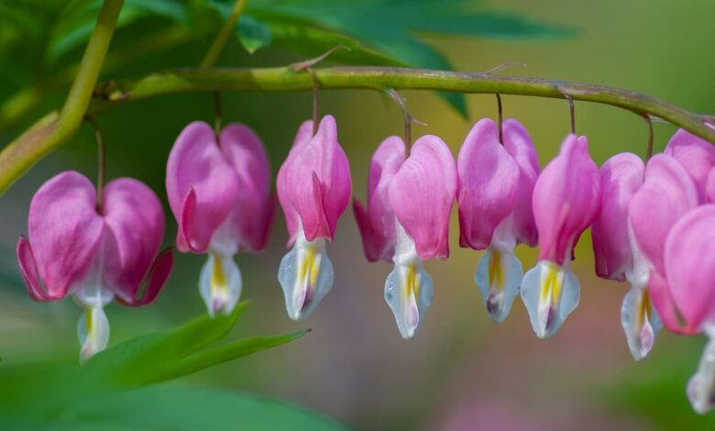
    - Carronia vine: vital for survival of rare moth (pink underwing moth):

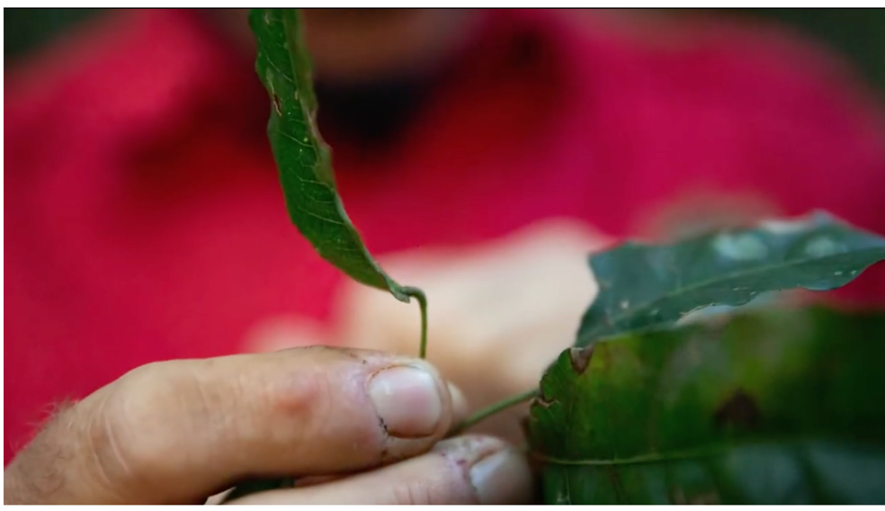 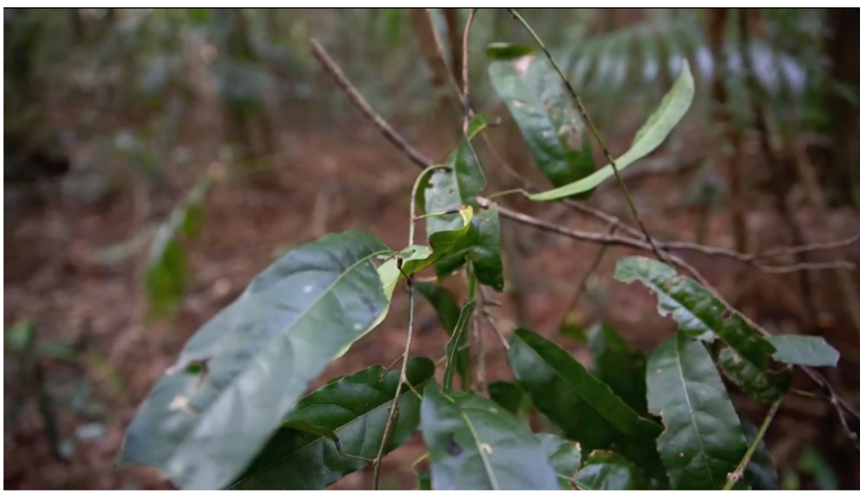

* + - Conjevoi:

Birds:

* + - Eastern yellow robin:A bird on a person's hand

      Description automatically generated
    - Rufous fantail:

* + - Regent Bowerbird:A black and yellow bird on a branch

      Description automatically generated
    - Rose crowned fruit dove:

